The biggest problem I had with my mobile design lied inside my login page. The main issue was the size of the content in the main body of the page.

I had already added a nice nav bar to both the pages for up to 700px and greater than 700px pages, and most of the sizing issues were resolved in last weeks module. I could of course add more breakpoints or try to find a way to display a mobile page better on tablets, but I didn’t go that far this week.

The idea for the other sections is to provide linkage into an RSS feed of articles for each topic, and perhaps even giving users the option to add and remove topics from the navbar, using the topic names as tags towards what articles would pop up in the RSS feed. I read extensively about RSS feeds and this seems to be what I need to do with this site eventually. If not for news in science topics, the site could be retrofitted for any tailored experience. I feel I did a good job giving users a good idea of their position in the site by utilizing the border property in CSS to highlight the location of their navigation.

The main changes I decided to focus on are entirely on the log in page. Increasing the size of buttons, increasing the size of the labels, increasing the size of all the other text that appears on this page and making use of all the whitespace tha that a skinny phone screen is offering me, and the matching the style to the desktop version to maintain a certain level of consistency.

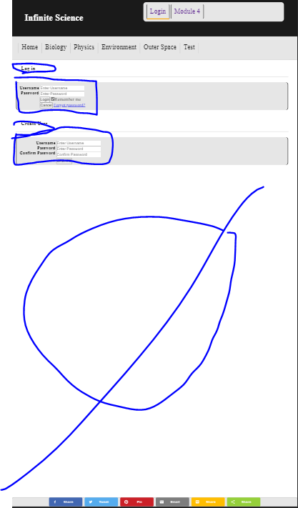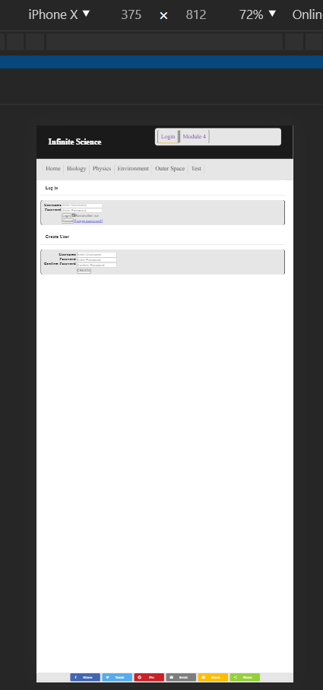

This above turned into this below:

iPhone X

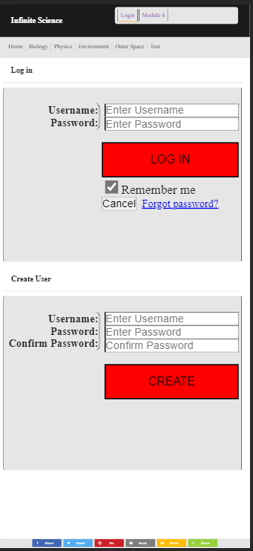

iPhone X landscape

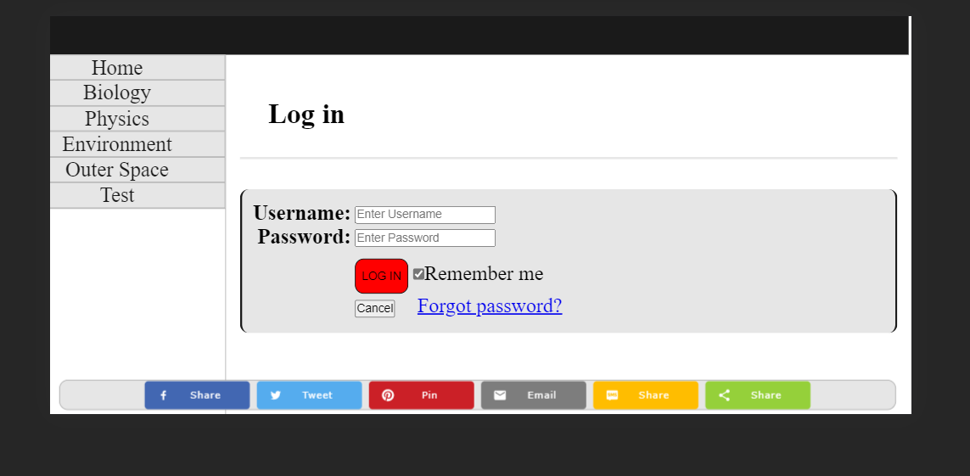

And the desktop version:

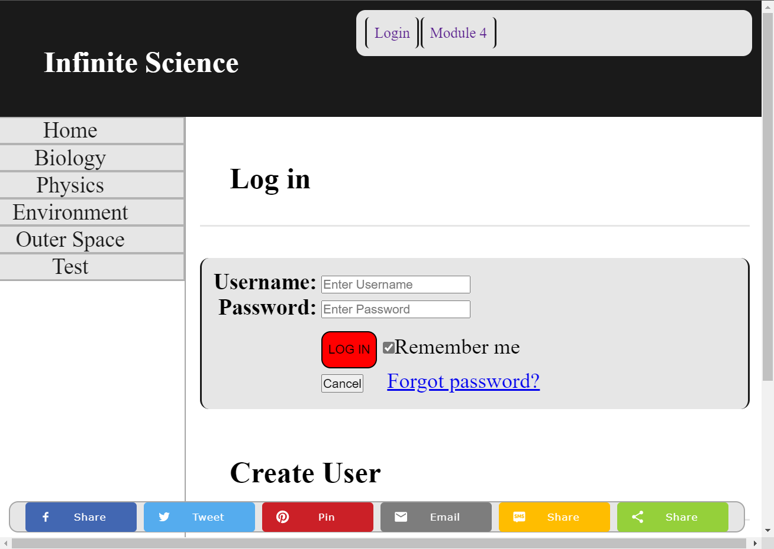

The landscape version seems to work out with the changes I made to the desktop version. I think it makes sense to give users two different display methods. I’m not sure it’s safe to assume users would view the pages in vertical orientation, but if they switch to landscape it almost makes sense that it would display in desktop mode – especially since the way its configured to fit mobile would be more inconvenient for users in landscape anyway.

Another approach that I could take is to put the log in and creation side by side or placing create account on an entire separate page, then taking the extra room to decorate the pages more.